

**Main project**

**Report on**

**Online Shopping System**

By

Harishma banu N

B.E

Batch: 2020-5351

Centre:Chrompet

Under the Guidance of,

**Jayanth v**

Technical trainer

**Edubridge**

(School of coding)

Online Shopping City

1. **Introduction**

**Online Shopping** **City** is a form of E-commerce which allows consumers to directly buy goods or services from a seller over the internet using a web browser. Consumers find a product of interest by visiting the website of the retailer directly or by searching among alternative vendors using a shopping search engine, which displays the same product's availability and pricing at different e-retailers.

1. **Scope**

Purchasing and selling products and services over the internet without the need of going physically to the market is what online shopping all about. Online shopping is just like a retail store shopping that we do by going to the market, but it is done through the internet.

**3. Advantages of the new system proposed**

a) Choose products faster and easier at one place.

b) Saves time of travelling to the vendor/seller’s place.

c) Good/Trusted & Tension free delivery services. Products bought online will be delivered to the footsteps of the buyer free of cost (may be varied based on the vendor/seller).

d) Alerts and real time reporting through Emails (to both vendor as well as buyer).

e) Reports generated can be saved for future references.

f) Inventory reports for the vendor/seller on daily, monthly, yearly basis.

**3.** **REQUIRMENT AND SPECIFICATIONS**

**HARDWARE SPECIFICATION**

Processor: Any Processor above 1.5 GH

RAM: 4 GB.

Hard Disk: 1 TB.

**SOFTWARE SPECIFICATION**

Frontend Platform: HTML-5, Bootstrap-4, JavaScript, Ajax, jQuery.

Backend Platform: Java-JSP/Servlet, My SQL.

Software: Eclipse Neon.

Operating System: Windows-10, Linux.

**4.** **Project Modules**

**A) Customer Module**

1) Customer Account Registration.

2) Customer Login.

3) Customer Settings.

4) Customer Products Carts.

5) Customers Password Change.

6) Online Product Views Category Wise.

a) Home

b) Men’s & Women’s wear

c) Electronics

d) Home Appliances

e) Makeup Products

f) Groceries

g) Vegtables & Fruits

h) Kids Section

i) Musical Instruments

j) Sports & Fitness

k) Fasion Jewellery

l) Pet Supplies

7) About Us.

8) Contact Us.

9) Rate this website

**B) Admin Module**

**a) Products.:**

1) Add Products/ Edit/ Delete.

2) View Products.

**b) Orders.:**

1) View All Orders.

2) View Pending Orders.

3) View Delivered Orders.

**c) Customers.:**

1) View Customers/ Delete.

2) View Contacts.

**d) Accounts.:**

1) My Accounts.

2) Change Password.

**5. Database Structure**

**Tables.:**

1) tbladmin

2) tblcaptcha

3) tblcart

4) tblcontact

5) tblcustomer

6) tblorders

7) tblproduct

**Query:**

Create Database name as **onlineshoppingsystem**.

CREATE TABLE `tbladmin` (

`id` bigint NOT NULL AUTO_INCREMENT,

`added_date` datetime NOT NULL,

`email` varchar(100) NOT NULL,

`password` varchar(100) DEFAULT NULL,

`name` varchar(100) DEFAULT NULL,

PRIMARY KEY (`id`),

UNIQUE KEY `UK_c0r9atamxvbhjjvy5j8da1kam` (`email`)

) ENGINE=MyISAM AUTO_INCREMENT=2 DEFAULT CHARSET=latin1;

CREATE TABLE `tblcaptcha` (

`captcha` varchar(100) DEFAULT NULL

) ENGINE=InnoDB DEFAULT CHARSET=utf8mb4 COLLATE=utf8mb4_0900_ai_ci;

INSERT INTO `tblcaptcha` VALUES ('13042');

UNLOCK TABLES;

CREATE TABLE `tblcart` (

`id` bigint NOT NULL AUTO_INCREMENT,

`discount_price` varchar(200) DEFAULT NULL,

`quantity` int NOT NULL,

`total_price` varchar(200) DEFAULT NULL,

`customer_id` bigint NOT NULL,

`product_id` bigint NOT NULL,

`mrp_price` varchar(200) DEFAULT NULL,

PRIMARY KEY (`id`),

KEY `CART_CUST_FK` (`customer_id`),

KEY `CART_PROD_FK` (`product_id`)

) ENGINE=MyISAM AUTO_INCREMENT=40 DEFAULT CHARSET=latin1;

CREATE TABLE `tblcontact` (

`id` bigint NOT NULL AUTO_INCREMENT,

`contact_date` timestamp NULL DEFAULT CURRENT_TIMESTAMP,

`email` varchar(50) NOT NULL,

`message` varchar(1000) NOT NULL,

`name` varchar(50) NOT NULL,

`subject` varchar(50) NOT NULL,

PRIMARY KEY (`id`)

) ENGINE=MyISAM AUTO_INCREMENT=5 DEFAULT CHARSET=latin1;

CREATE TABLE `tblcustomer` (

`id` int DEFAULT NULL,

`address` varchar(255) NOT NULL,

`added_date` timestamp NULL DEFAULT CURRENT_TIMESTAMP,

`email` varchar(100) NOT NULL,

`gender` varchar(6) NOT NULL,

`name` varchar(50) NOT NULL,

`password` varchar(60) NOT NULL,

`phone` varchar(200) DEFAULT NULL,

`valid` varchar(50) DEFAULT NULL,

`pin_code` varchar(255) NOT NULL,

UNIQUE KEY `UK_dwk6cx0afu8bs9o4t536v1j5v` (`email`),

UNIQUE KEY `UK_o3uty20c6csmx5y4uk2tc5r4m` (`phone`)

) ENGINE=MyISAM DEFAULT CHARSET=utf8;

CREATE TABLE `tblorders` (

`id` int NOT NULL AUTO_INCREMENT,

`order_no` int DEFAULT NULL,

`customer_name` varchar(200) DEFAULT NULL,

`mobile_number` varchar(100) DEFAULT NULL,

`email_id` varchar(100) DEFAULT NULL,

`address` varchar(400) DEFAULT NULL,

`address_type` varchar(100) DEFAULT NULL,

`pincode` varchar(100) DEFAULT NULL,

`image` varchar(200) DEFAULT NULL,

`product_name` varchar(400) DEFAULT NULL,

`quantity` int DEFAULT NULL,

`product_price` varchar(100) DEFAULT NULL,

`product_selling_price` varchar(100) DEFAULT NULL,

`product_total_price` varchar(100) DEFAULT NULL,

`order_status` varchar(100) DEFAULT NULL,

`order_date` timestamp NULL DEFAULT CURRENT_TIMESTAMP,

`payment_mode` varchar(100) DEFAULT NULL,

`payment_id` int DEFAULT NULL,

PRIMARY KEY (`id`)

) ENGINE=InnoDB AUTO_INCREMENT=20 DEFAULT CHARSET=utf8mb4 COLLATE=utf8mb4_0900_ai_ci;

CREATE TABLE `tblproduct` (

`id` bigint NOT NULL AUTO_INCREMENT,

`active` varchar(100) DEFAULT NULL,

`code` varchar(5) DEFAULT NULL,

`create_date` timestamp NOT NULL DEFAULT CURRENT_TIMESTAMP,

`description` varchar(255) DEFAULT NULL,

`image` varchar(100) DEFAULT NULL,

`image_name` varchar(400) DEFAULT NULL,

`name` varchar(30) DEFAULT NULL,

`price` varchar(200) DEFAULT NULL,

`mrp_price` varchar(200) DEFAULT NULL,

`product_category` varchar(100) DEFAULT NULL,

PRIMARY KEY (`id`),

UNIQUE KEY `UK_h3w5r1mx6d0e5c6um32dgyjej` (`code`)

) ENGINE=MyISAM AUTO_INCREMENT=37 DEFAULT CHARSET=latin1;

**6. Reporting**

In this module all reports will be generated. Whenever an item is sold, or customer orders a product, its vendor should be sent an alert via email immediately so that he can ship that item soon. This module has 3 sub modules like a **Stock Reports, Order Reports** & **Delivery Reports**

**Stock Report**

will produce reports of the quantity of the products available and product status.

**Order Report**

will have the list of products ordered and the customer details who have bought that product, which are undelivered.

**Delivery Reports**

will generate products list, which are delivered to customers?

**7. Future scope of the Project**

a) Most generic consumer to consumer e-commerce website, which covers almost all possible categories.

b) Maximize benefits and minimize the disadvantages of a common e-commerce website.

c) User friendly, Vendor friendly environment.

**Home page:**

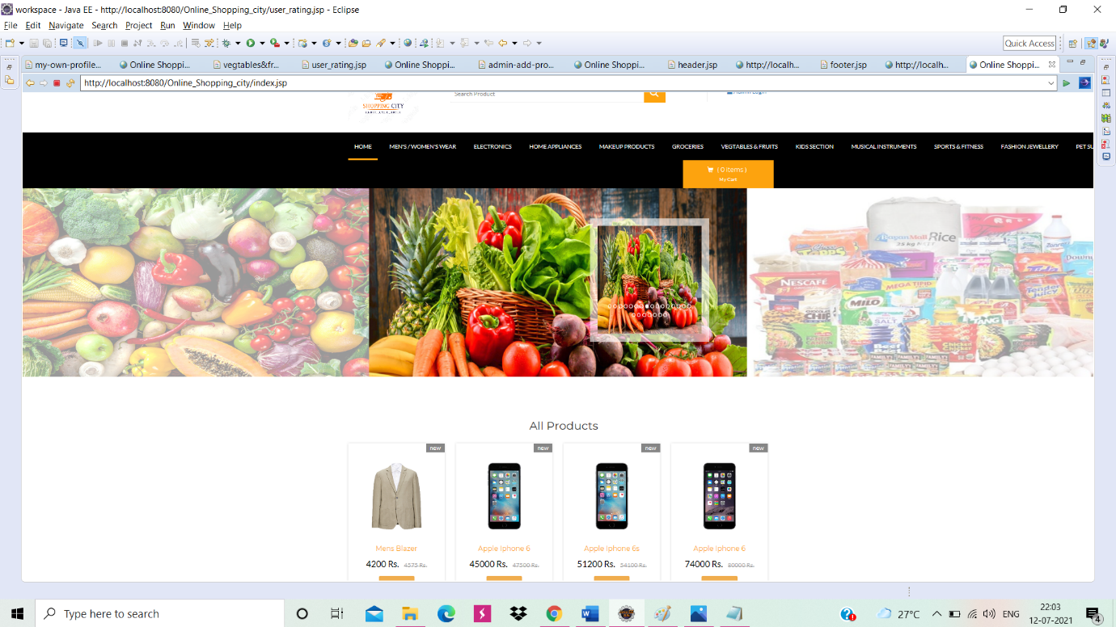

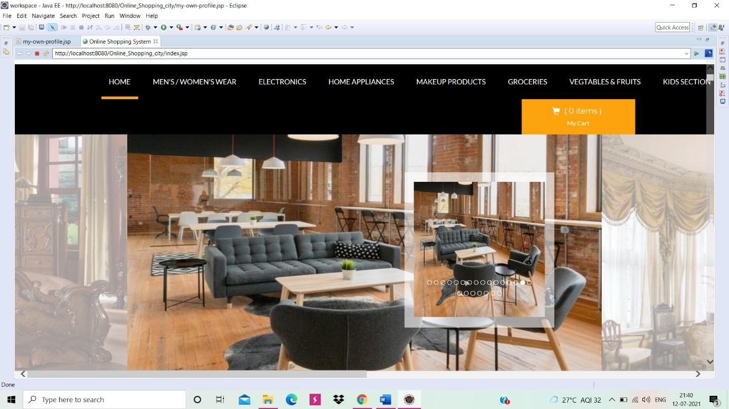

Create a Account Page:

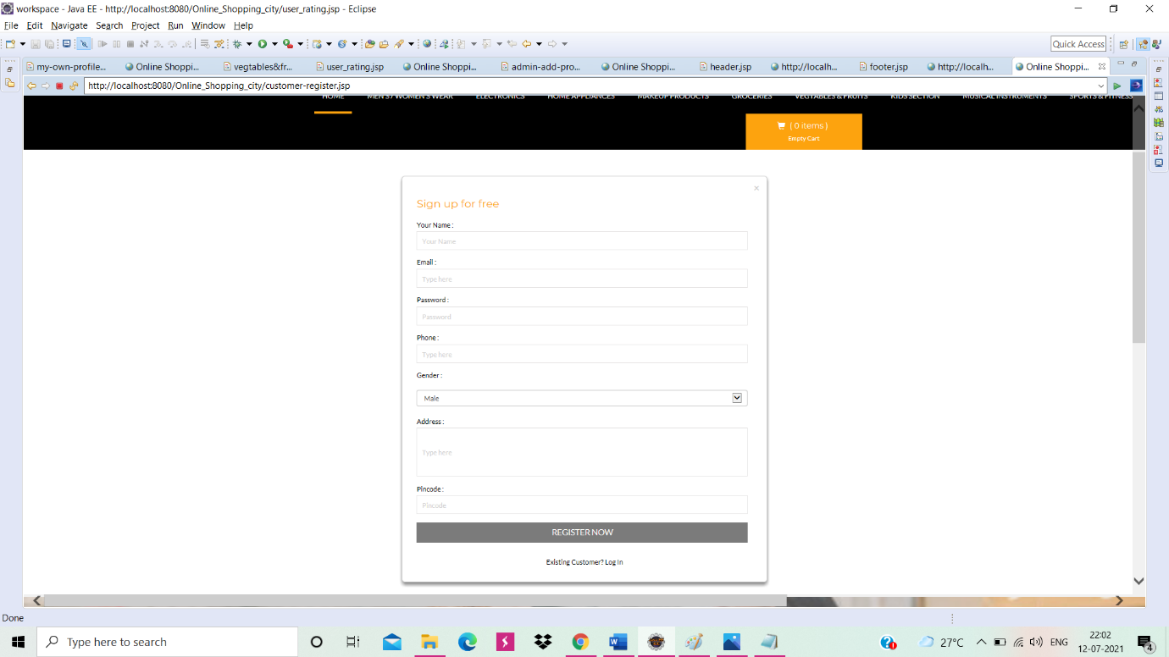

Sign In Page:

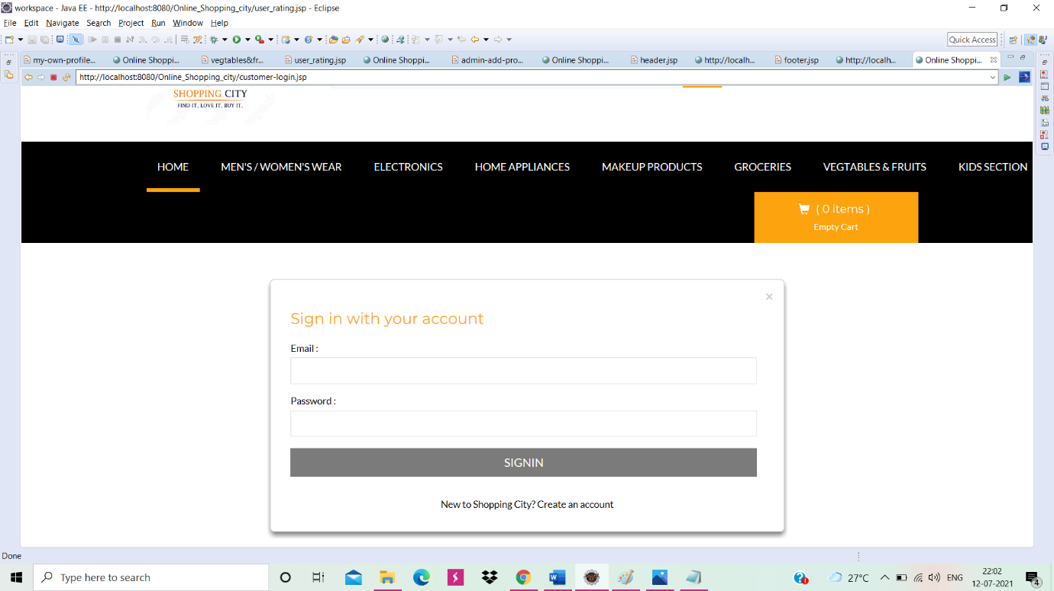

All Products Page:

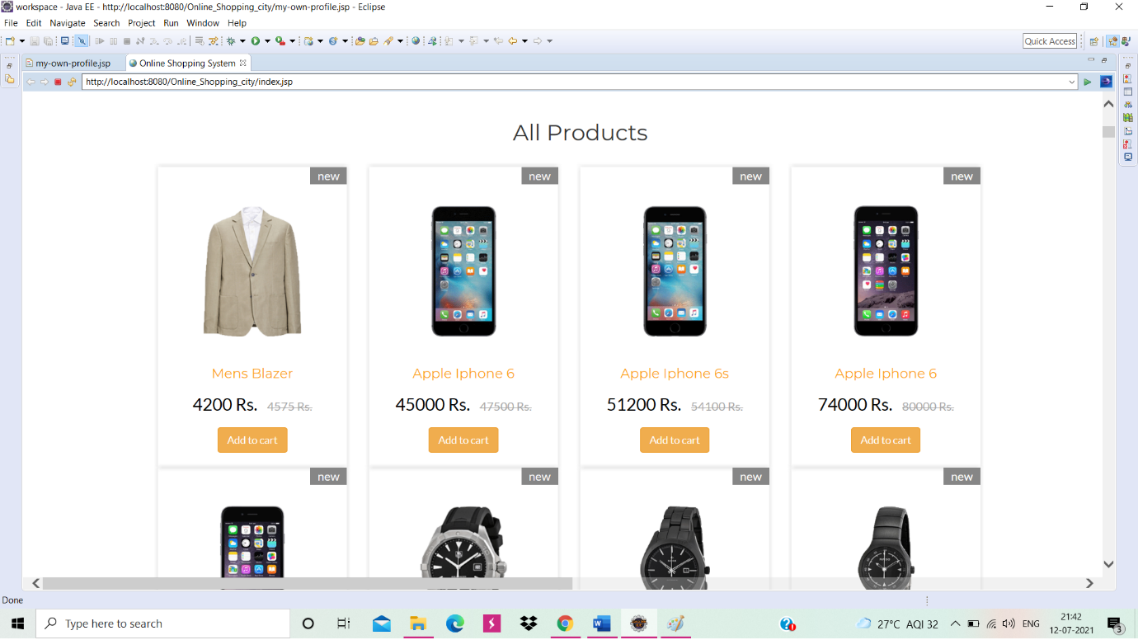

Vegtables& Fruits Page:

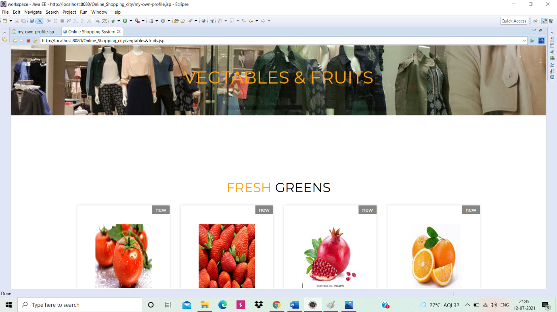

My Cart :

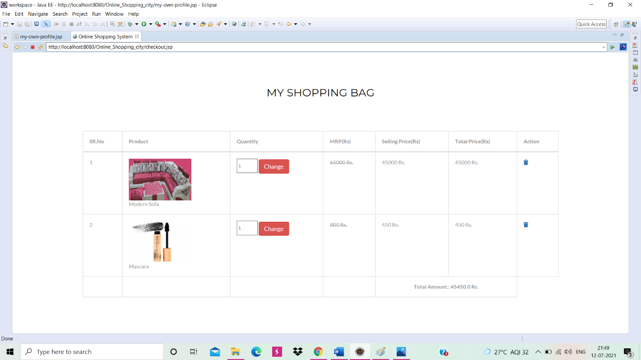

After Buyed the Product :

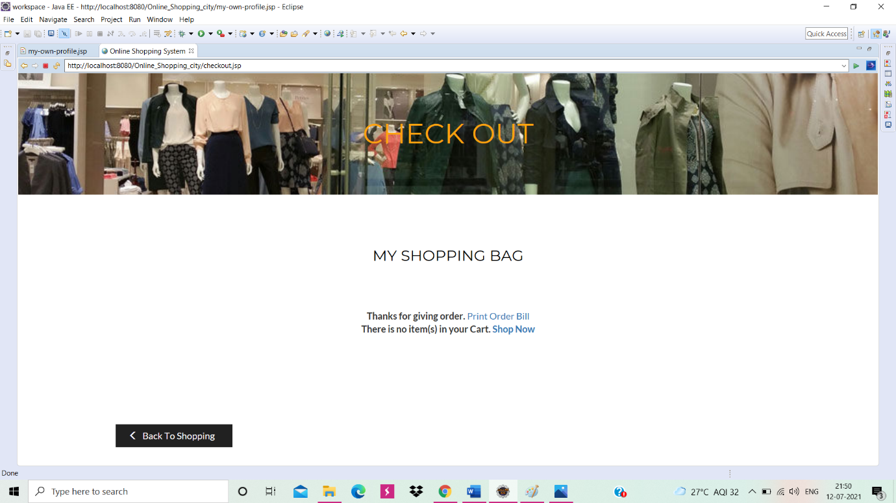

Delivered orders Page:

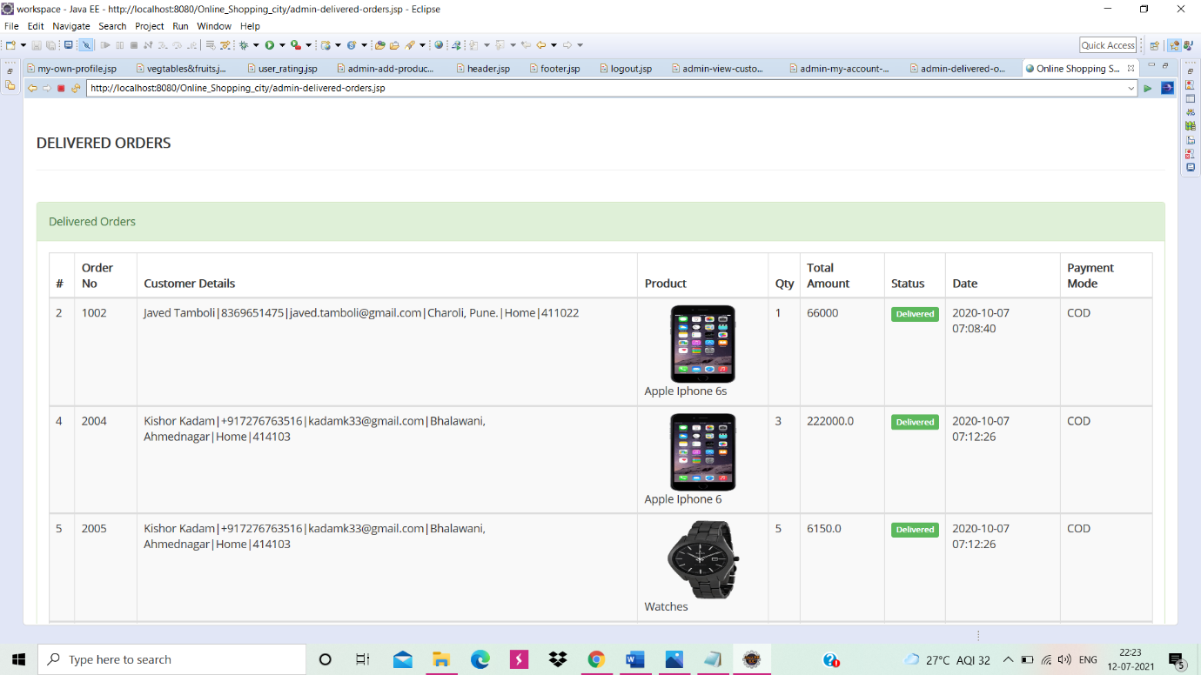

Pending orders Page:

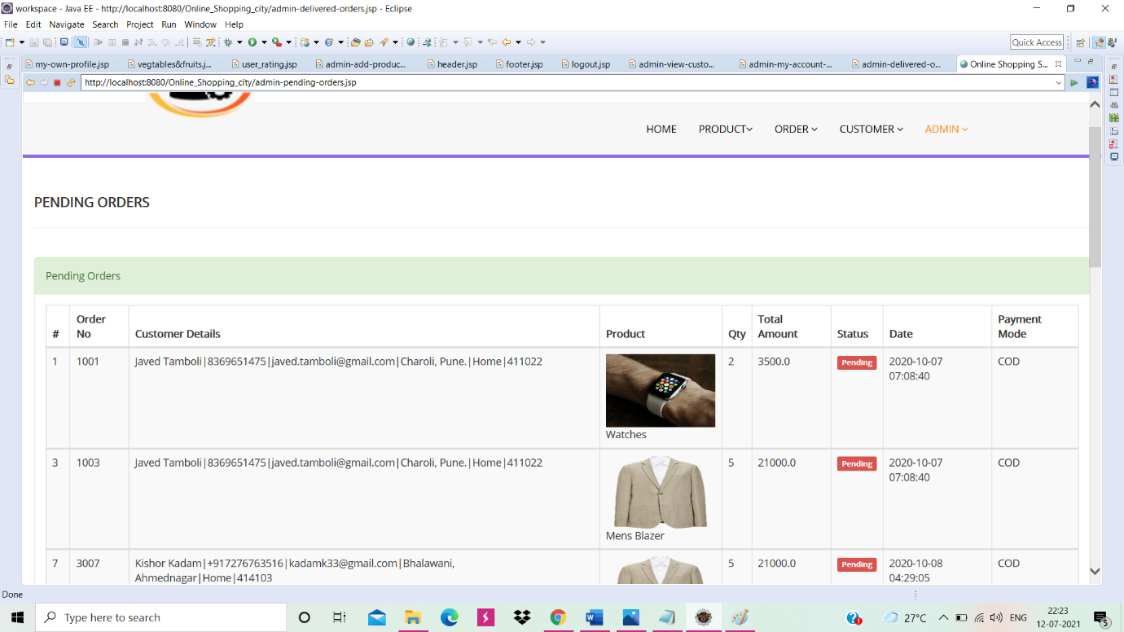

Header Page:

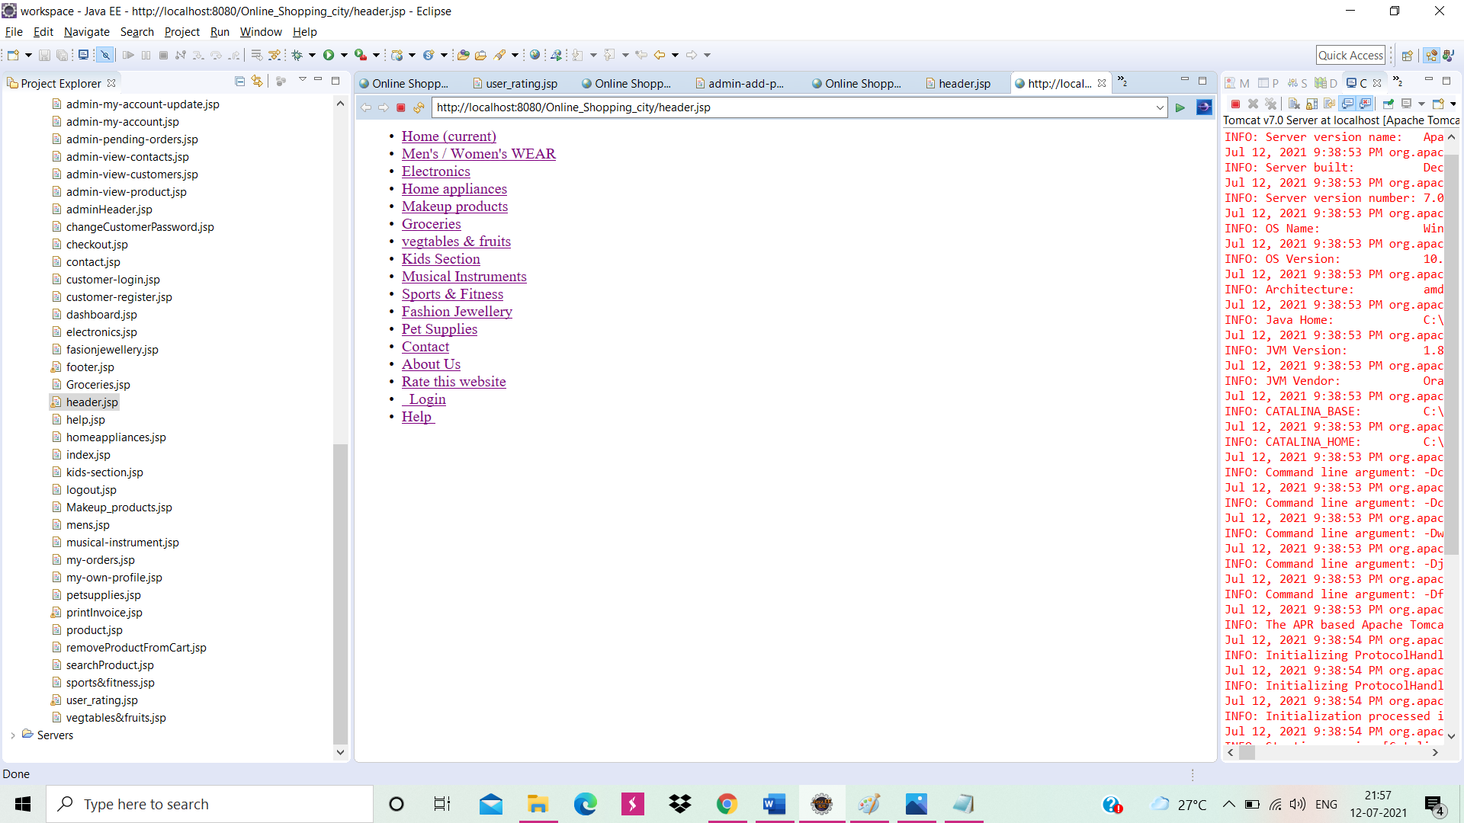

Footer Page:

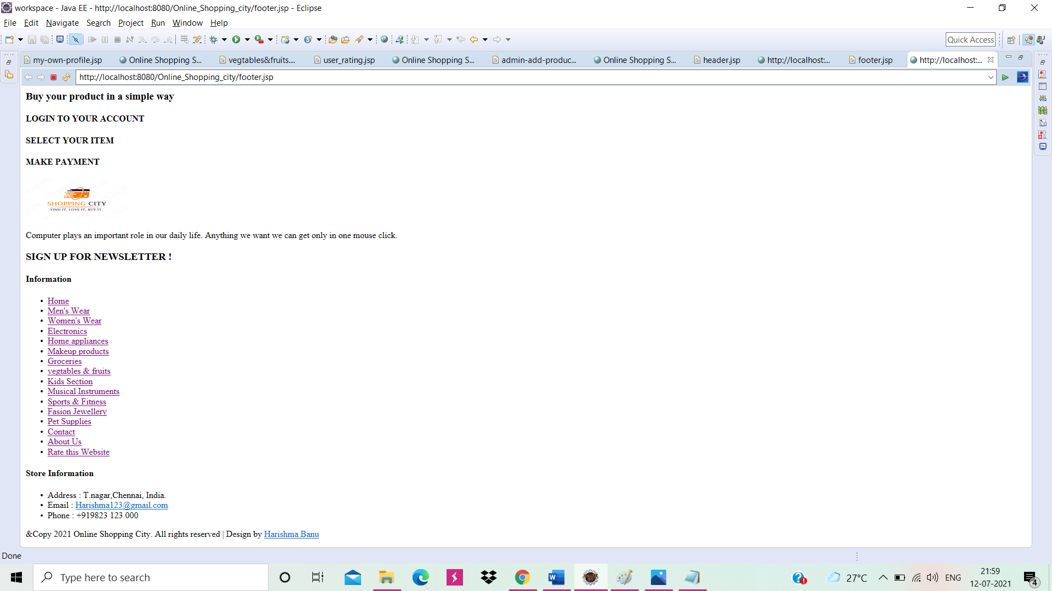

Admin Login Page:

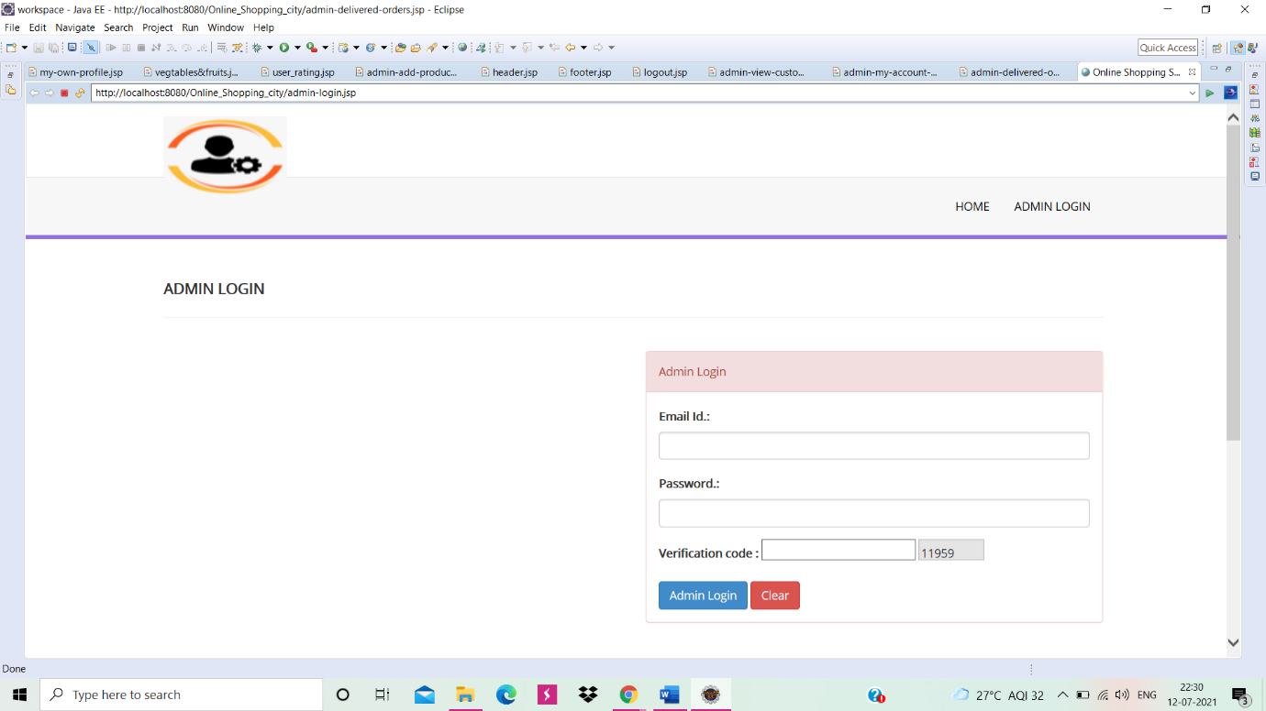

Admin Home Page:

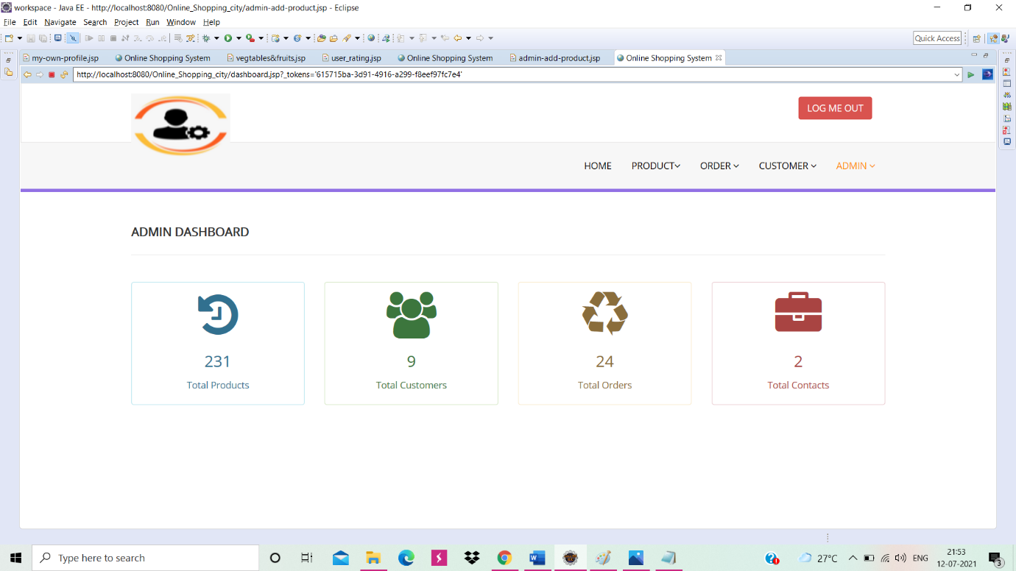

View Product page:

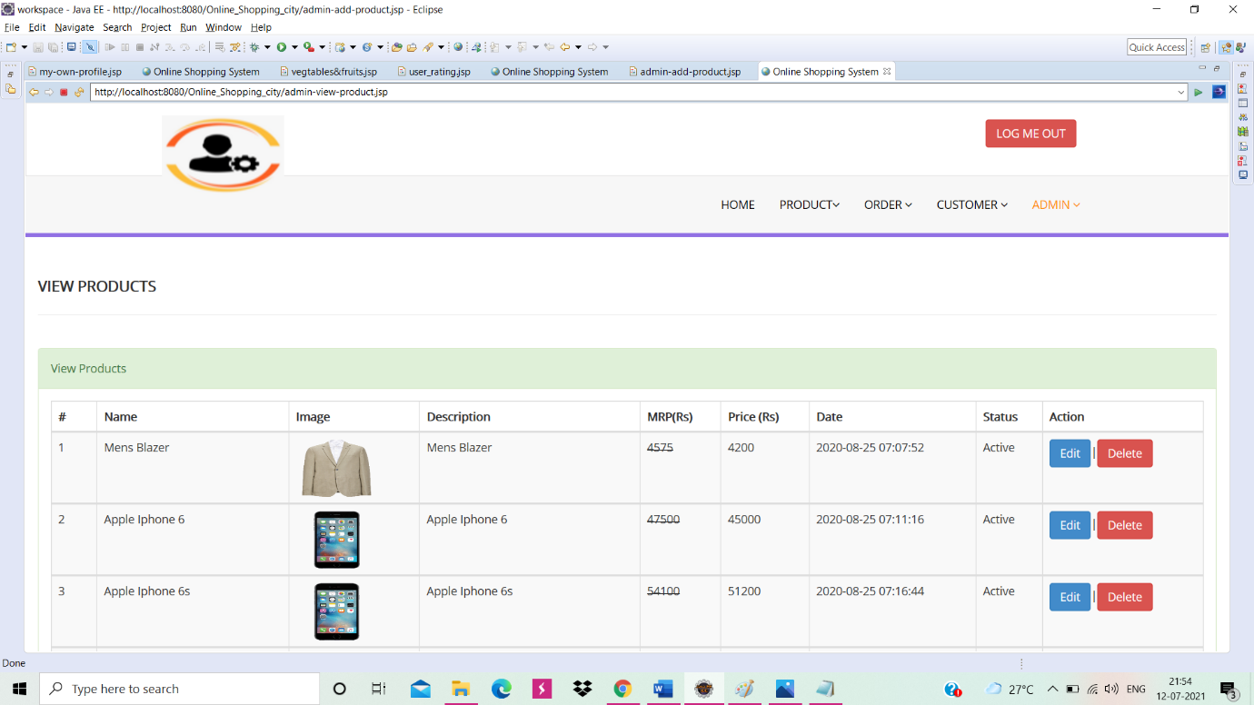

All orders List page:

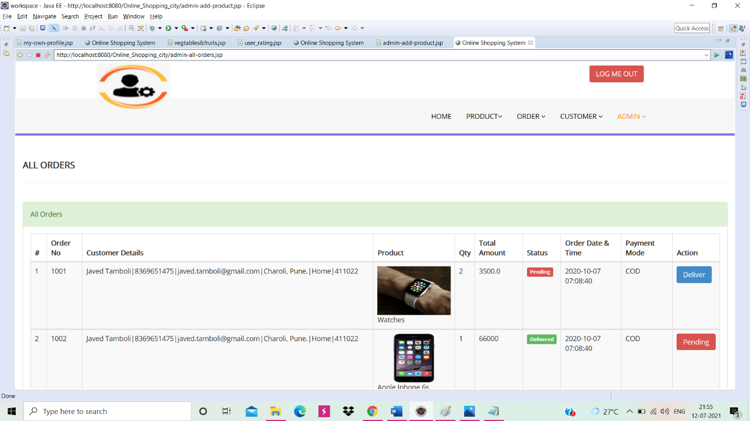

View Customers Page:

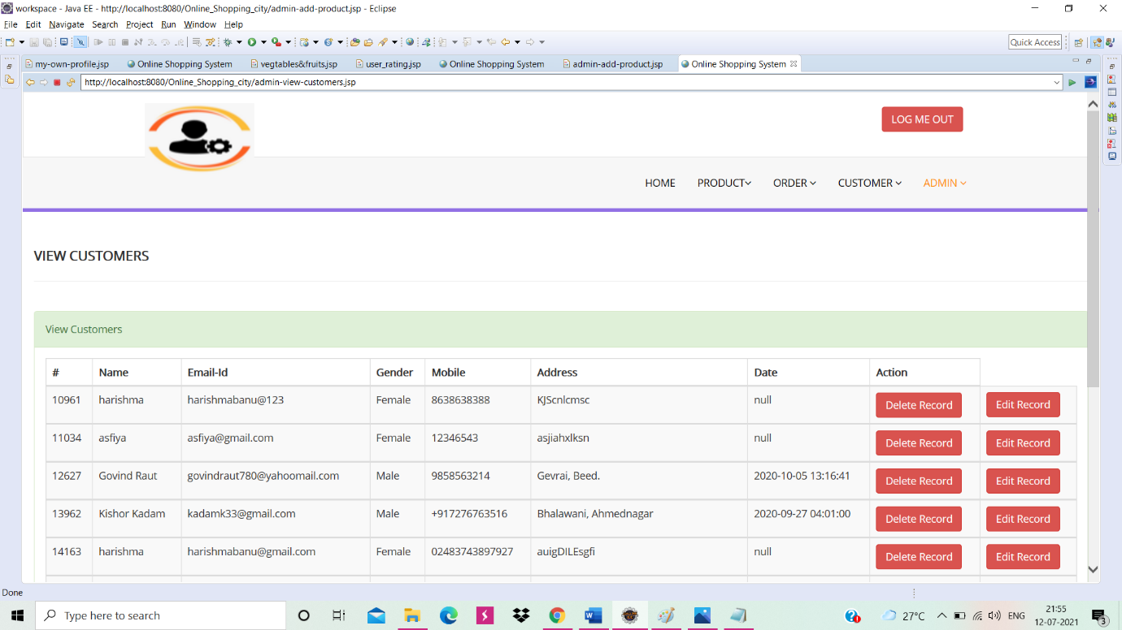

View Contacts Page:

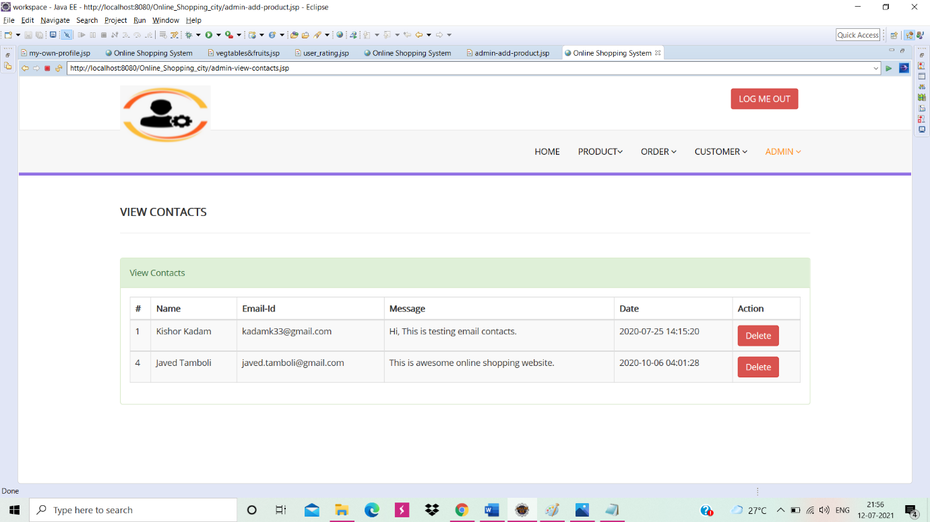

Admin Account Page:

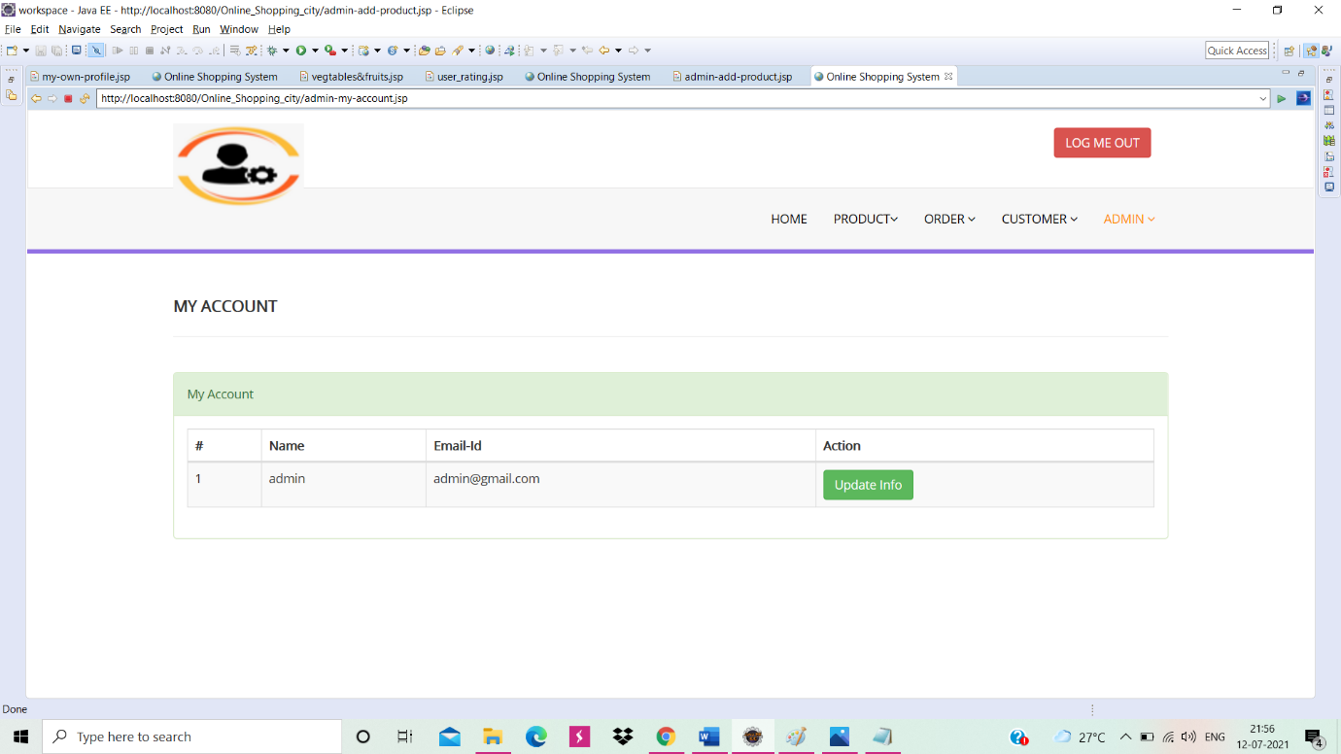

Rate This Website Page:

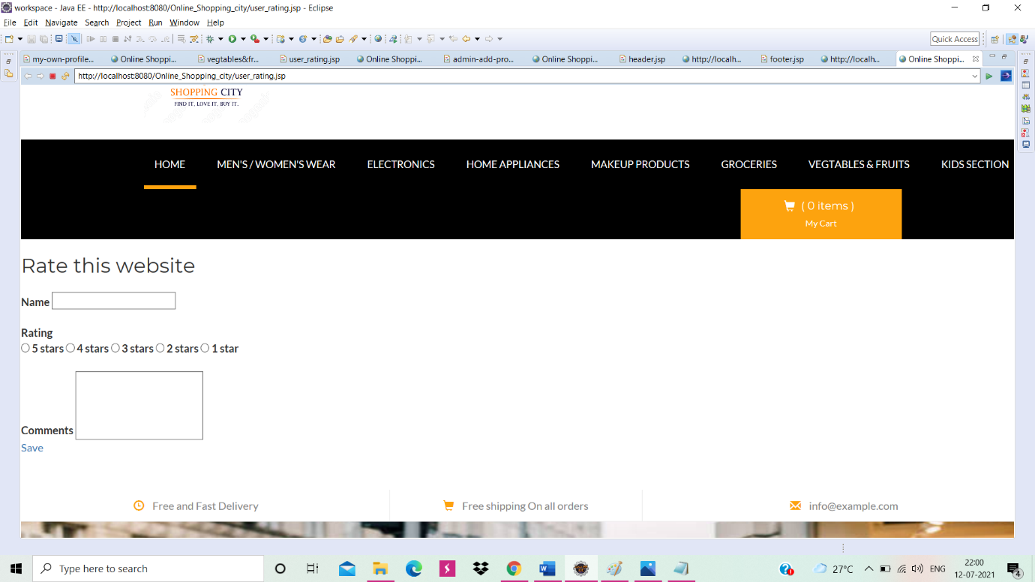

About Us Page:

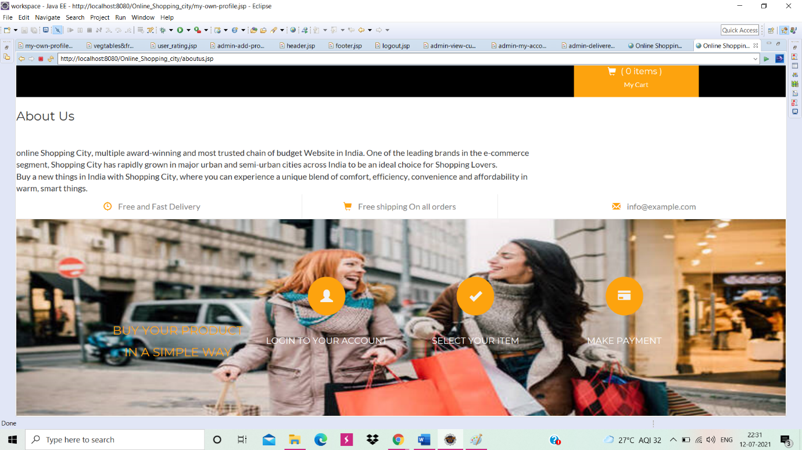

**Thank you**